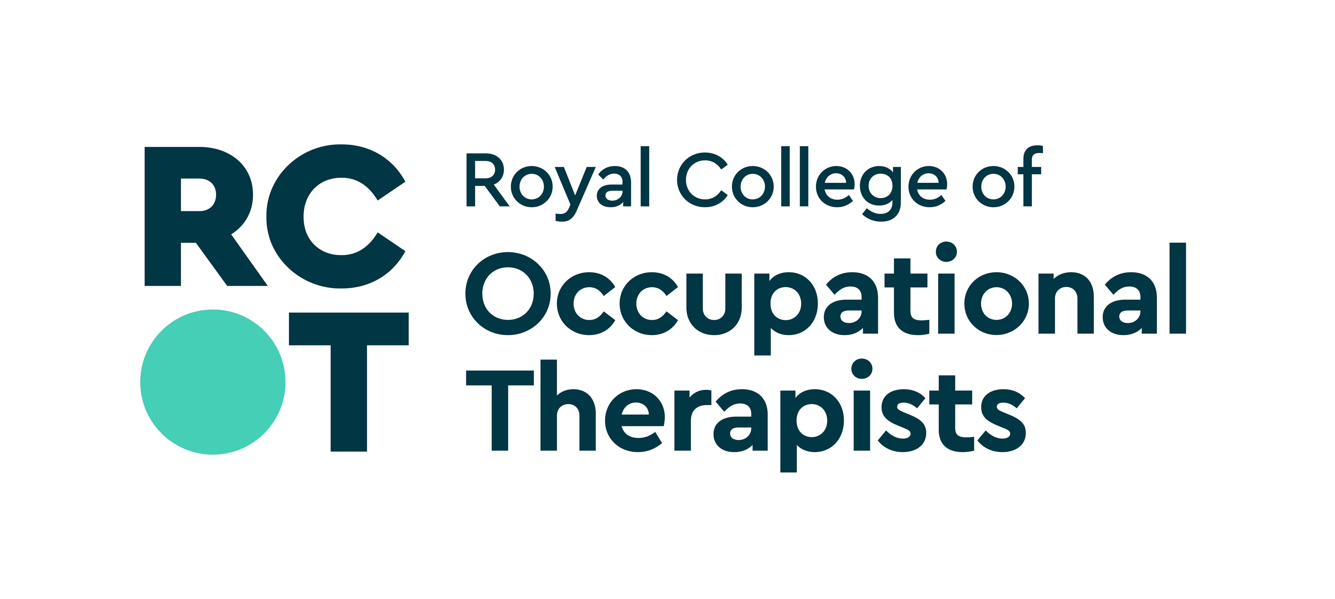

Policy on Conflicts of Interest

Introduction

The British Association and Royal College of Occupational Therapists (BAOT/RCOT) value the involvement of their members, colleagues, partners and employees to support and enable the organisation’s work.

Conflicts of interest are not uncommon when individuals undertake different roles with different responsibilities. The issue is not the integrity of the individuals involved but the management of any potential to profit from the individual’s position or for the individual to be influenced by conflicting loyalties. Therefore, it is necessary to reduce or eliminate any risk of bias that might affect the efficient running of BAOT/RCOT.

A conflict of interest is identified as either a personal (of the person, their partner or close relatives) or a non-personal (of their department/employer/business) interest, which could have the potential to influence or affect an individual’s ability to act in the best interests of BAOT/RCOT. Interests may be financial or non-financial, or commercial. Interests can be considered as either ‘specific’ or ‘non-specific’ in relation to the matter under discussion.

Purpose

This policy aims to help individuals covered by its scope to identify, manage and declare anything professional, personal or non-personal to them that could conflict with the interests and efficient running of BAOT/RCOT and its standing within the professional community in which it operates.

Responsibilities

When dealing with the business of BAOT/RCOT, the overriding duty is to act only in the best interests of the organisation, (which, in practice, means RCOT members), putting these before any other personal or professional interests. This duty overrides all other considerations.

All individuals covered by this policy must:

- Act in the best interests of BAOT/RCOT at all times.
- Not benefit from their office or position as trustee, director, representative or employee.
- Not put themselves in a position where their interests conflict with those of BAOT/RCOT.

Declarations required

Any individual covered by this policy is required to declare:

1. Any professional, personal or non-personal interest, either financial or non-financial, which might be seen or be expected to allow them to benefit in some way and which might impinge on the interests or efficient running of BAOT/RCOT.

2. Any interest in the topic under discussion and/or development, which creates a real danger of bias, for example if the interest affects them personally or professionally.

3. Any interest which might reasonably cause others to think it could influence their decision, even if, in reality, it does not create a real danger of bias.

4. Specific interests to be declared may include:

- Ordinary membership of professional bodies, specialist sections (or similar), committees, charities, voluntary bodies, etc.
- Offices held in professional bodies, specialist section committees, charities, voluntary and private sector organisations.
- Commercial interests, consultancies, directorships or advisory positions.
- Authoring or co-authoring of professional reports/publications/evidence.
- Public appointments, research positions, contracts and secondments.

If in any doubt about the application of these rules, consult the chair of the meeting or group or other relevant person, for example the Chief Executive, BAOT/RCOT officer or project manager.

Manner and form of declaration

Declarations of conflicts of interest are made verbally and in writing as follows:

- Annual written declarations should be made on the declaration form (Appendix A) to indicate whether or not the individual making the declaration has anything to declare and giving a description of the conflict of interest.
- Written declarations must be made when a situation arises that may result in a conflict of interest and as confirmation of verbal declarations made at a meeting, where the conflict of interest is of sufficient importance and/or is likely to continue.
- All meetings involving individuals covered within the scope of this policy should have a regular agenda item at the beginning of the meeting requiring anyone present to make a declaration of any conflict of interest.
- All declarations must be recorded in the minutes together with the outcomes.

Register of Interest

The organisation holds a register of interests to assist with identifying conflicts of interest.

Declaration forms should be completed and signed annually and when any new, (actual or potential) conflict of interest arises, as described above. The register is held securely by the Senior Governance and Executive Support Officer and is available to the Chair, Chief Executive and auditors.

Consequences of declarations

The immediate consequence of a declaration is that the individual making it should seek to mitigate its effects. This may be achieved by distancing him/herself from the situation causing the conflict of interest by withdrawing from the meeting, group or activity, either totally or during that agenda item, discussion or task. However, with agreement of the Chair and other meeting/group members, it may be possible to contribute to the discussion/work and, if appropriate, take part in any voting.

The nature, management and outcomes of any conflict of interest must be recorded in the meeting minutes.

Consequences of failure to declare

If an individual has failed to make a declaration of interest, this should be brought to the attention of the Chief Executive or Chair who will decide on appropriate action.

Original: November 2012
Revised: January 2022

Appendix A

Conflicts of interest declaration form

BAOT/RCOT value the involvement of their members, colleagues, partners and employees in supporting and enabling the organisation’s work. Conflicts of interest are not uncommon when individuals undertake different roles with different responsibilities. Individuals covered by the Policy on Conflicts of Interest are required to complete a declaration form.

A conflict of interest is identified as either a personal (of the person, their partner or close relatives) or a non-personal (of their department/employer/business) interest, which could have the potential to influence or affect an individual’s ability to act in the best interests of BAOT/RCOT. Interests may be financial or non-financial, or commercial. Interests can be considered as either ‘specific’ or ‘non-specific’ in relation to the matter under discussion.

Name of Committee, Group or other project:

Type of interest | Description of interest  (if you have no interests in a category, state none)
Ordinary membership of professional bodies, specialist sections, committees, charities, voluntary bodies, etc. | Name of body
Office held in professional bodies, specialist sections, committees, charities, voluntary bodies, etc. | Name of body and nature of office held
Consultancies, directorship or advisory positions. | Name of companies and position(s) and associated dates
Other – please specify

Signature: ………………………………………………………………….………………………………….

Name: ……………………………………………………..…………. Date: ………………………………

Job title: ………………………………………………….. Employer: ……………………………………..

A copy of the Royal College of Occupational Therapists’’ Conflict of Interest Policy can also be accessed on the website at:
https://www.rcot.co.uk/about-us/governance/council-and-boards/royal-college-occupational-therapists-council

Return this form to: Senior Governance and Executive Support Officer, Royal College of Occupational therapists, 106-114 Borough High Street, London SE1 1LB dominique.lemarchand@rcot.co.uk

