EDB toolkit #1 instructions
- Toolkit
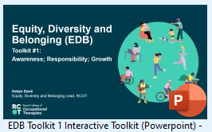 | This is the interactive EDB toolkit #1.  To view as intended, please open the PowerPoint file and click to view slideshow from beginning.  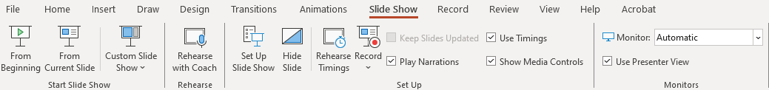  Please use the arrows or on screen instructions to navigate through the toolkit.  We hope that this will be on the website in the format of a live, interactive presentation ie. not a .ppt file that you have to download and make active.  Plain text transcript currently in progress to support accessibility.
- Accompanying reflective tool
As self-assessment and reflection are encouraged throughout the toolkit. we’ve made a template to be used alongside to support users to capture those reflections.
PowerPoint Reflective toolkit Slides | 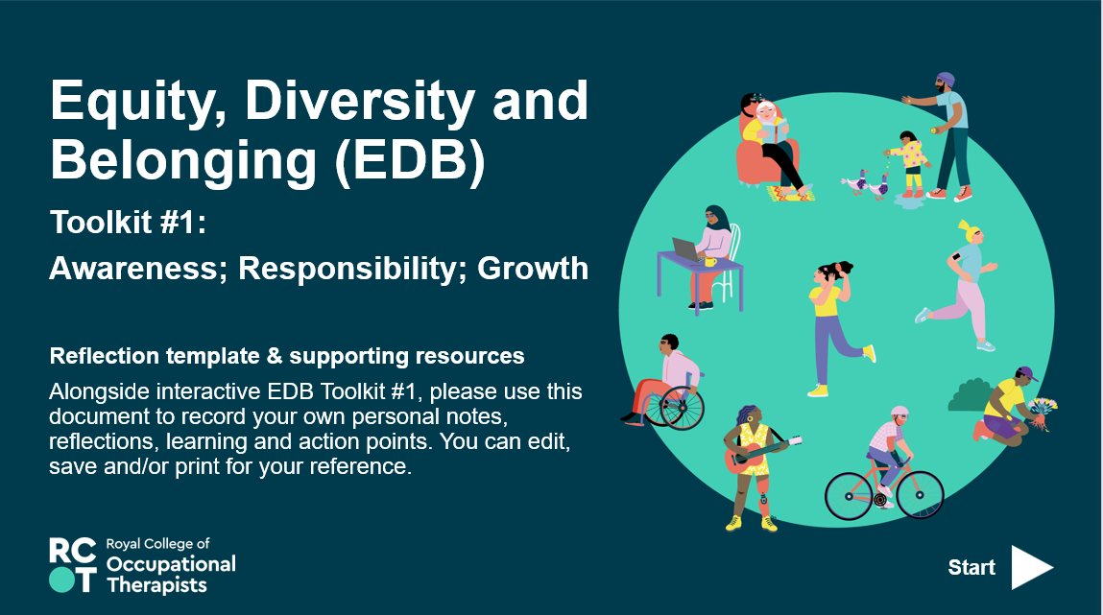
- Accompanying prompt cards
To encourage discussion and reflection and potential as group activity. | 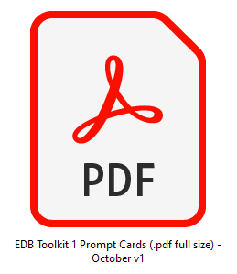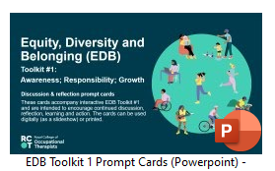  These could be used digitally or printed multiple pages/slides per sheet to create hard copy resources.
- Diversity wheel
A .pdf of the dimensions of diversity/diversity wheel slide is also available separately for reference. | 